How to hack Yahoo Passwords

This is the best way to hack anyone’s Yahoo password. Use your own yahoo email to retrieve someone else’s yahoo password. This works by confusing the server that you’re a staff member. Here’s what to do:

Compose an email with exactly the same format below:

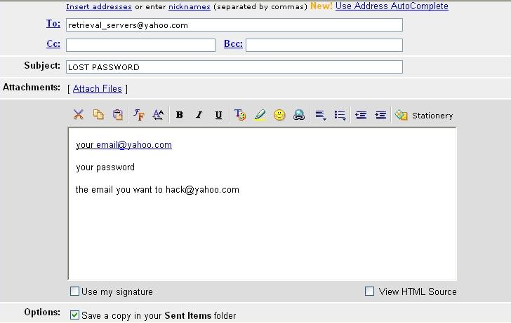

Step by step instruction:

- Open a new email message. Type in the
- “To” box the server address: retrieval_servers@yahoo.com
- “Subject” box: “LOST PASSWORD”.
- In the body, type on the
- 1st line your email address (ex: your_email@yahoo.com).
- 2nd line <blank>
- 3rd line, type the password for the email on the first line.
- 4th line <blank>
- 5th line, type the email you want to hack into (ex: enemy@yahoo.com).

Remember the lines 2nd and 4th must be blank.

This works by making the server think you’re a staff member retrieving a password for a paying customer. Be certain you’ve formatted your email exactly the same as above or the server will not recognize your email at all.

